**WASHplus Project**

**1825 Connecticut Avenue, NW**

**Washington, DC 20009-5721**

**www.washplus.org**









**Essential WASH actions for Neglected Tropical Diseases Prevention**

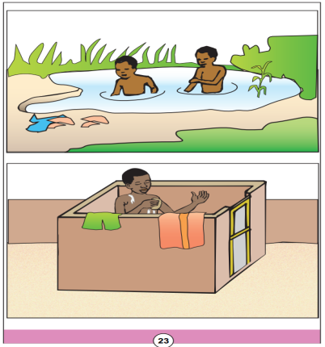

**Card 23: Swimming**

QUESTIONS

Q1 : What do you see on these images?

Q2 : What do you think about these images?

KEY MESSAGES TO REMEMBER

- Let’s not urinate / swim / wade / bath in open water source

- Let’s build and use latrines for our baths

How to use the counseling cards

1. Develop the topic with additionnal information
2. Do not be too technical, speak the language that your audience can understand
3. Ask reminder questions to check what the audience has retained
4. Synthesize the essence of what needs to be retained
5. Move to the next card
6. Thank the audience at the end of the session
7. Give a precise date for the next appointement.
8. Chose a place where all your audience may well see the images
9. Greet your audience in their language
10. Hold the card so that the audience sees the image and not the text
11. Introduce the topic with an open question
12. Involve the audience. Ask questions and encourage discussion
13. Accept all answers and sort the good ones by emphasizing them positively
14. Summarize the good answers

|  |  |  |
| --- | --- | --- |
| **INDEX** | | |
| **Thèmes développés** | **Card Number** | **Target Neglected Tropical Diseases** |
| Drug taking during mass distribution campaigns | Card 1 | Schistosomiasis, Soil Transmitted Helminths, Trachoma |
| Ensure environmental cleanliness: The gap story | Cards 2-3 |
| The drawbacks of open air defecation | Card 4 |
| The benefits of owning latrines | Card 5 |
| Let’s keep our latrines clean | Card 6 |
| Let’s not defecate outside / Let’s not urinate outside | Card 7 |
| Appropriate feces disposal | Card 8-9 |
| Critical hand washing times | Cards 10-11 |
| Right way of hand washing | Card 12 |
| Intestinal worms transmission mode | Card 13 | Soil Transmitted Helminths |
| Water transportation | Card 14 |
| Drinking water treatment | Card 15 |
| Drinking water storage | Card 16 |
| Drinking water use | Card 17 |
| Food hygiene | Card 18 |
| Critical shoes wearing times | Card 19 |
| Fixed hand washing device with soap in the household | Card 20 |
| Schistosomiasis transmission modes | Card 21 | Schistosomiasis |
| Doing laundry | Card 22 |
| Swimming | Card 23 |
| Fishing | Card 24 |
| Farming | Card 25 |
| Trachoma transmission modes | Card 26 | Trachoma |
| Face washing | Card 27 |